Feb 12th 2020.

Virtual environment setup:

Python 3.6.7 65-bit (“virpy3.6”:venv)

Tensorflow-gpu==1.14.0

No more error when installing these.

Jupyter Binder <https://jupyter.org/binder>

<https://github.com/jupyterhub/binderhub>

* Similar to docker to make sure the correct version/environment when running/development programs.

VSCode (Visual Studio Code) <https://code.visualstudio.com/>

* Very good for debugging especially working with server environment.

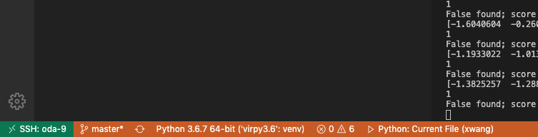

* Need to set up the config for Remote Explorer, you will see and work with all the folders/files on server.

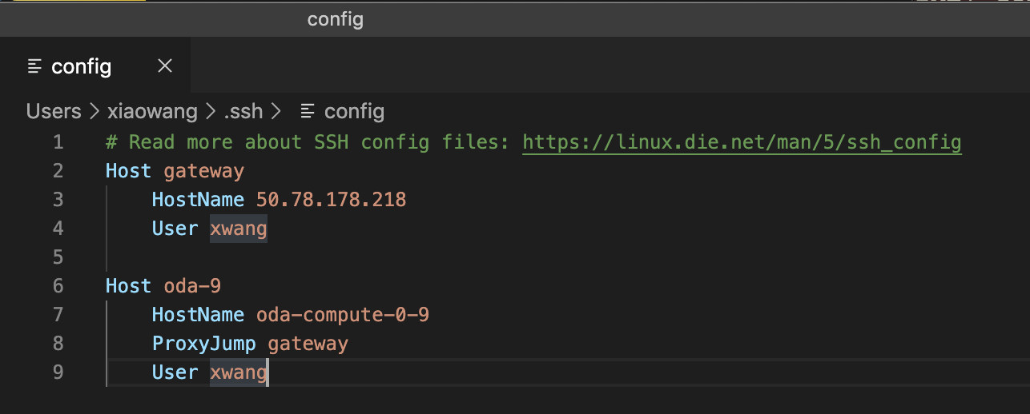

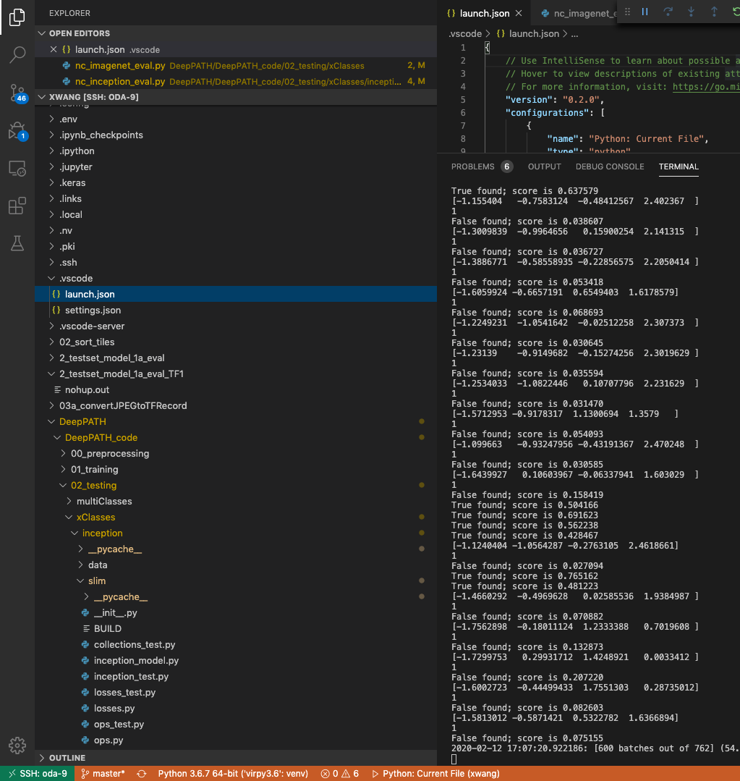

* When debugging, use step in, step over, step out and continue. You can also use DEBUG console to print out every line or variables of desire.
* Use launch.json file to feed in command line argument for python script.

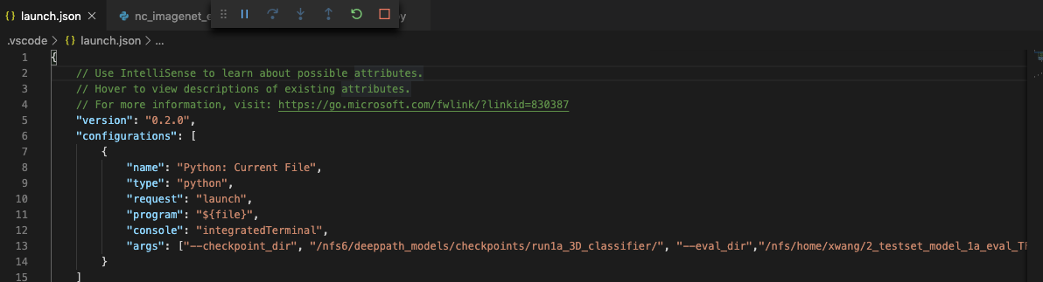

Solved the error problem:

Need to set the num of class to 3. DeepPATH 1a model is using 3 class (normal/LUAD/LUAD). The DeepPATH scripts nc_imagenet_eval.py is not fixable with number of classes I think. And because we are loading the previous saved model, our parameters for number of classes should match with their save model, otherwise, Invalid Argument. <https://github.com/ncoudray/DeepPATH/tree/master/DeepPATH_code/example_TCGA_lung/checkpoints>

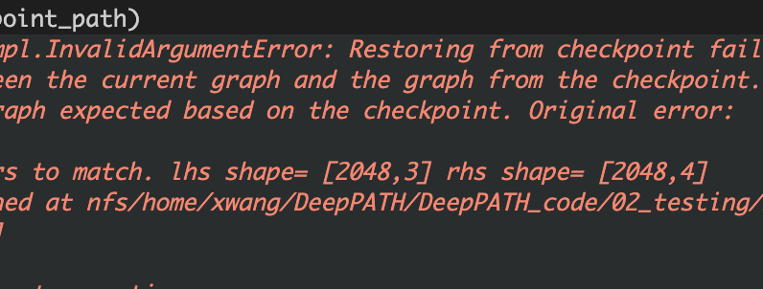

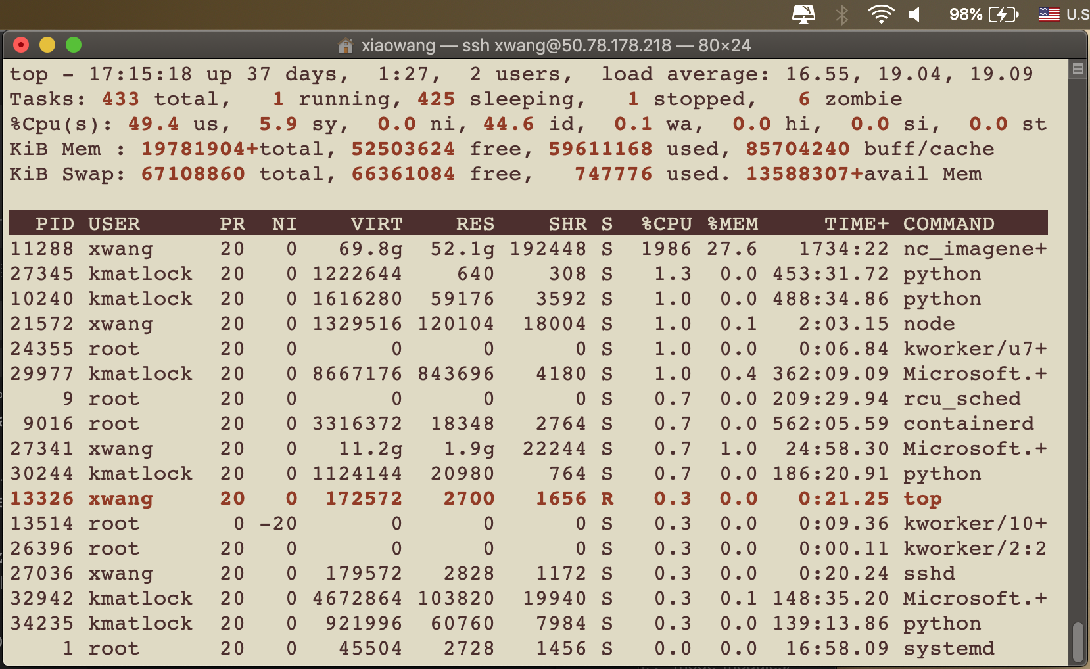

Next Step:

1. Waiting for this 1a model to finish and check the result. Current result is running test TFRecords for inference.
2. We could change parameters in previous pre-processing steps to larger value for background filtering, so that the quality of these image may result in better accuracy.
3. Clarifying how DeepPATH calculate the results / accuracy with softmax.

nohup python /nfs/home/xwang/DeepPATH/DeepPATH_code/02_testing/xClasses/nc_imagenet_eval.py --checkpoint_dir=/nfs6/deeppath_models/checkpoints/run1a_3D_classifier/ --eval_dir=/nfs/home/xwang/2_testset_model_1a_eval_TF1/ --data_dir=/nfs/home/xwang/03a_convertJPEGtoTFRecord/03a_TFRecord_test/ --batch_size 30 --ImageSet_basename='test_' --run_once --ClassNumber 3 --mode='0_softmax' --TVmode='test'

Image Processing Project:

Cross correlation registration

Watershed

During interview meeting, the introductions of oda:

OpenMrs (reference schema for EHR dataset) <https://openmrs.org/>

OpenMRS是一个协作性开源项目，旨在开发软件以支持发展中国家的医疗保健。 OpenMRS建立在开放性和共享思想，软件以及部署和使用策略的原则之上。该系统设计为可在资源非常匮乏的环境中使用，并且可以通过添加新的数据项，表格和报告进行修改，而无需进行编程。

Design[[edit](https://en.wikipedia.org/w/index.php?title=OpenMRS&action=edit&section=2)]

The OpenMRS code is based on a "concept dictionary" that describes all the data items that can be stored in the system such as clinical findings, laboratory test results or socio-economic data. This approach avoids the need to modify the database structure to add new diseases, for example, and facilitates sharing of data dictionaries between projects and sites.[[12]](https://en.wikipedia.org/wiki/OpenMRS#cite_note-AboutOpenMRS-12) An important feature of OpenMRS is its modular construction which allows the programming of new functions without modifying the core code. OpenMRS is web based but can be deployed on a single laptop or on a large server and runs on [Linux](https://en.wikipedia.org/wiki/Linux), [Windows](https://en.wikipedia.org/wiki/Microsoft_Windows) or [Mac OS X](https://en.wikipedia.org/wiki/Mac_OS_X).[[3]](https://en.wikipedia.org/wiki/OpenMRS#cite_note-Download-3)

Other key features of OpenMRS:

* Built on the [MySQL](https://en.wikipedia.org/wiki/MySQL) database[[2]](https://en.wikipedia.org/wiki/OpenMRS#cite_note-FAQ-2) (but uses [Hibernate](https://en.wikipedia.org/wiki/Hibernate_(Java)) allowing it to be ported to other databases)
* Programmed in [Java](https://en.wikipedia.org/wiki/Java_(programming_language))[[2]](https://en.wikipedia.org/wiki/OpenMRS#cite_note-FAQ-2)
* Includes tools for data export and reporting
* Versions currently exist for [HIV/AIDS](https://en.wikipedia.org/wiki/AIDS), [Drug resistant TB](https://en.wikipedia.org/wiki/Multi-drug-resistant_tuberculosis), [primary care](https://en.wikipedia.org/wiki/Primary_care) and [oncology](https://en.wikipedia.org/wiki/Oncology)
* Supports open standards for medical data exchange including [HL7](https://en.wikipedia.org/wiki/HL7),[[2]](https://en.wikipedia.org/wiki/OpenMRS#cite_note-FAQ-2) [FHIR](https://en.wikipedia.org/wiki/Fast_Healthcare_Interoperability_Resources), [LOINC](https://en.wikipedia.org/wiki/LOINC) and IXF
* Form-based tools, such as the Form Entry module[[12]](https://en.wikipedia.org/wiki/OpenMRS#cite_note-AboutOpenMRS-12) and [XForms](https://en.wikipedia.org/wiki/XForms" \o "XForms) module[[2]](https://en.wikipedia.org/wiki/OpenMRS#cite_note-FAQ-2)
* Provides access to between-release code through "Continuous Deployment"[[13]](https://en.wikipedia.org/wiki/OpenMRS#cite_note-13)
* Bidirectional synchronization with systems such as MoTeCH[[*expand acronym*](https://en.wikipedia.org/wiki/Wikipedia:Manual_of_Style#Acronyms_and_abbreviations)] and TRACnet[[*expand acronym*](https://en.wikipedia.org/wiki/Wikipedia:Manual_of_Style#Acronyms_and_abbreviations)]
* The Atlas module, which gives information on all OpenMRS facilities using a visual map
* Can be integrated with [SMS](https://en.wikipedia.org/wiki/Short_Message_Service) messaging

<https://en.wikipedia.org/wiki/List_of_open-source_health_software>

GenomicsDB <https://www.genomicsdb.org/>

<https://github.com/GenomicsDB/GenomicsDB/wiki>

-> UCLA ib2b

This is also part of GATK pipline use for multivariant prediction.